Flights of Imagination: The Story of Icarus in Poetry
with Guilford Poet Laureate Mark McGuire-Schwartz

Tuesday, April 1, 2025 6:30 pm
Guilford Free Library
67 Park St, Guilford, CT
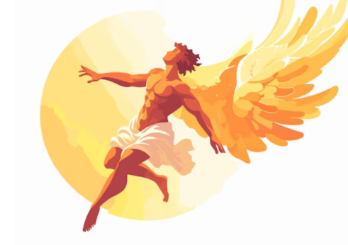
The ancient story of Icarus has inspired wide-ranging interpretations by W. H. Auden, William Carlos Williams, Muriel Rukeyser, and other great poets. In our exploration of their poems, we will delve into the Icarus myth and address some of these questions:
- Is Icarus brave or foolish? Or both?
- When is a bold action worth the risk?
- How much do you trust your parents? How well do you listen to them?
- What would Icarus be like as an adult? And more…

Guilford Poet Laureate Mark McGuire-Schwartz strives to find a tad of originality in this world so overcrowded with words. This led to his creating a new poetic form, the Seventeen. Further, he believes that he may be the first person to ever use the phrase “iffy, itchy, icy, insular” in a poem.

This program is free and open to all. Please register at the following link:
Flights of Imagination: The Story of Icarus in Poetry with Guilford Poet Laureate Mark McGuire-Schwartz – Guilford Free Library

